*Florida International University*

*School of Computing and Information Sciences*

Software Engineering Focus

Interactive Paint

User Story ID <327>

**Name:**

Daniel Mederos

**Team Member(s):**

Jim Louro

**Project:**

Interactive Paint

**Product Owner(s)**:

Francisco Ortega

**Mentor(s)**:

**Instructor**: Masoud Sadjadi

**User Story Name:** Create FILL

* Description: **As a** User **I would like** to create a fill **so that** it can fill an area in the GUI Canvas

Acceptance Criteria

* The fill should be able to be created on the GUI canvas (Devices we currently own)
* The dropdown menu with the brush draw button should be presented to the user
* The brush button in the dropdown menu when clicked should fill when input is clicked on GUI Canvas

**Use Case** Create a Fill in the GUI Canvas

|  |  |  |
| --- | --- | --- |
| #**344** Implement FILL | | |
| ***Description*** | When the user clicks on the fill button, the user should then be able to fill an area when he/she clicks on the GUI canvas | |
| ***Actor*** | User of Interactive Paint | |
| ***Precondition*** | GUI must be running | |
| ***Flow of Events*** | **User** | **System** |
| **1.** | User clicks on Brush button | A dropdown menu appears and the brush button appears |
| **2.** | User clicks on fill button | The mouse pointer is now active with the fill function |
| **3.** | User clicks on the GUI Canvas | The area closed off were the fill button is clicked inside of it, will fill the entire space with a color |

**Use Case Diagram**

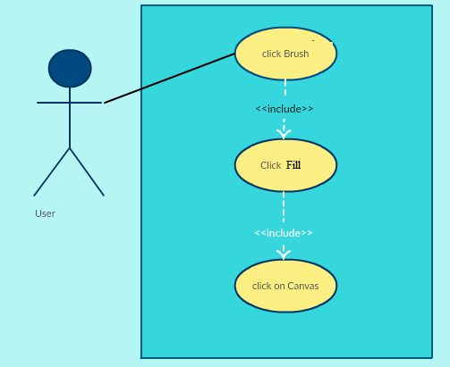

**Sequence Diagram**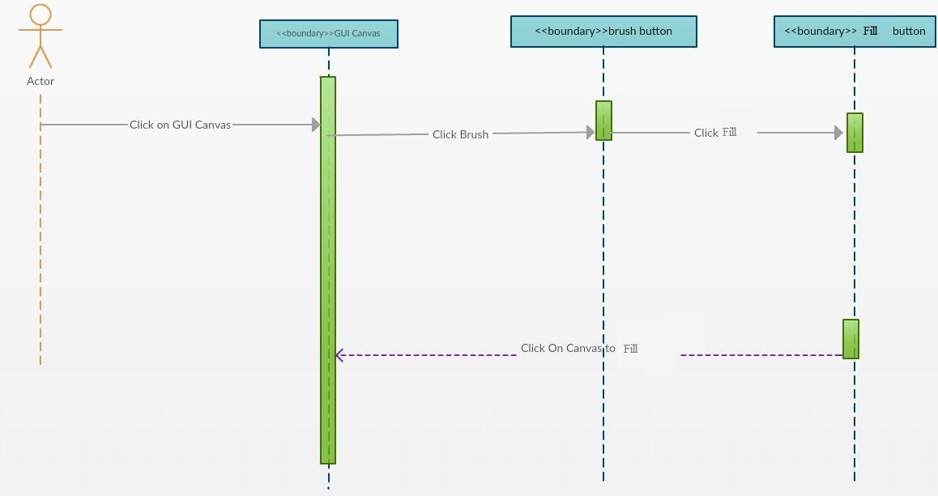

**Class Diagram**

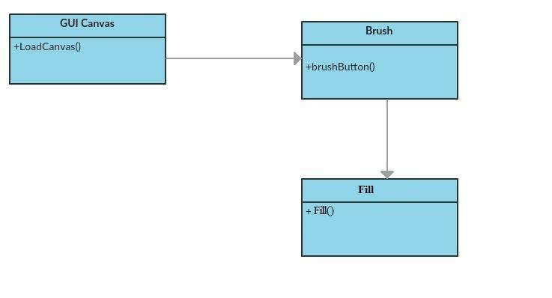

**Integration Test**

**Testing**

**Description:**

* Test the fill button and lets the user fill a closed area on the GUI canvas

**Work Log:**

**Unit Test**

**Test Case 1 (sunny)**

***Purpose:*** to test that the fill button appears when user clicks on fill button

* Precondition The user must have QT plugin for visual studio and must run the program
* Input: User clicks on brush button which then a drop down menu appears
* Expected Result: fill button appears on GUI Canvas from a drop down menu
* Actual Result: Actual result was found to be the expected result.
* Status: **PASSED**

**Test Case 2 (sunny)**

***Purpose:*** to test that the fill button properly lets the user fill a closed area on the GUI Canvas

* Precondition The user must have QT plugin for visual studio and must run the program
* Input: User clicks on brush button which then a drop down menu appears and must click fill
* Expected Result: filled area appears on GUI Canvas when clicked inside closed area
* Actual Result: Actual result was found to be the expected result.
* Status: **PASSED**

**Test Case 3 (rainy)**

***Purpose:*** to test that the fill button appears when user clicks on brush button

* Precondition The user must have QT plugin for visual studio and must run the program
* Input: User clicks on fill button which then a drop down menu appears
* Expected Result: fill button appears on GUI Canvas from a drop down menu
* Actual Result: Actual result was found to be the expected result.
* Status: **PASSED**

